Aim: Perform SQL injection attack. • Identify a web application vulnerable to SQL injection. • Craft and execute SQL injection queries to exploit the vulnerability.
Theory:
SQL Injection (SQLi) is a web security vulnerability that occurs when a web application improperly validates user input before using it in SQL queries. This flaw allows an attacker to manipulate the database query executed by the application. SQL injection can lead to unauthorized access to sensitive data, modification or deletion of database records, and even complete compromise of the application.
SQL injection is one of the most common and dangerous web application vulnerabilities. It usually occurs when user inputs from forms, search fields, login pages, or URL parameters are directly concatenated into SQL statements without proper validation or parameterization.
Working Principle
A typical web application interacts with a database using SQL queries. For example, during user authentication, the application checks the entered username and password against records stored in the database.
If the application directly includes user input in SQL queries without proper sanitization, malicious input can alter the intended query logic. This may allow an attacker to bypass authentication, retrieve confidential information, or manipulate database contents.
Types of SQL Injection
- In-band SQL Injection: The attacker uses the same communication channel to inject malicious SQL and receive the results.
- Blind SQL Injection: The application does not display database errors, so the attacker infers information from the application's responses.
- Time-based Blind SQL Injection: The attacker uses database time delays to determine whether injected conditions are true or false.
- Out-of-band SQL Injection: Data is extracted through a different communication channel, such as DNS or HTTP requests.
Effects of SQL Injection
Unauthorized access to confidential information.
Bypassing authentication mechanisms.
Reading, modifying, or deleting database records.
Compromising application integrity.
Loss of data confidentiality and availability.
Identifying SQL Injection Vulnerabilities
A web application may be vulnerable if:
User inputs are directly used in SQL queries.
Error messages reveal database information.
Input validation is weak or absent.
Dynamic SQL queries are created by concatenating user input.
Security professionals identify such vulnerabilities only in authorized testing environments using security assessment techniques and tools.
Prevention of SQL Injection
The following best practices help prevent SQL injection attacks:
Use parameterized queries (prepared statements).
Validate and sanitize all user inputs.
Use stored procedures securely.
Apply the principle of least privilege for database accounts.
Avoid displaying detailed database error messages.
Use web application firewalls (WAFs).
Perform regular security testing and code reviews.
Applications
Security auditing of web applications.
Penetration testing in authorized environments.
Secure software development and vulnerability assessment.
Cybersecurity education and training.
Conclusion
SQL Injection is a serious web application vulnerability caused by improper handling of user input. Understanding how SQL injection works helps developers build secure applications and enables security professionals to identify and remediate vulnerabilities during authorized security assessments. Implementing secure coding practices such as parameterized queries and proper input validation is essential for protecting web applications against SQL injection attacks.
Steps:
1. Extract the DVWA zip file.
2. Copy the folder and paste it in Drive C: > xampp > htdocs
3. Rename the file as DVWA.
4. Go in the config file and rename the file as config.inc.php
5. Open chrome and search localhost/DVWA.
6. Click on create/reset database. The database will be created. Click on login.
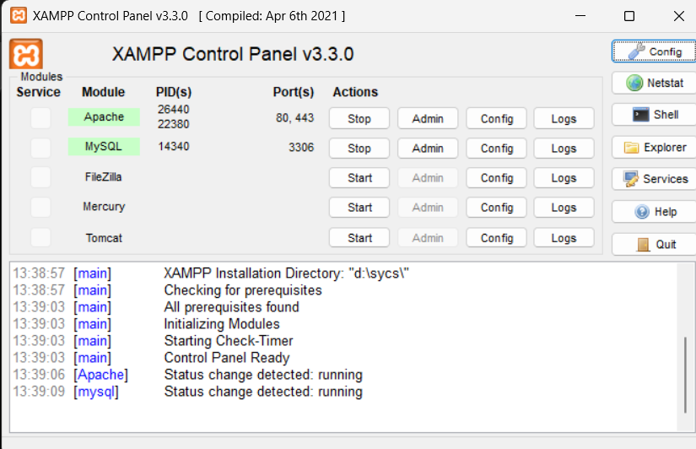
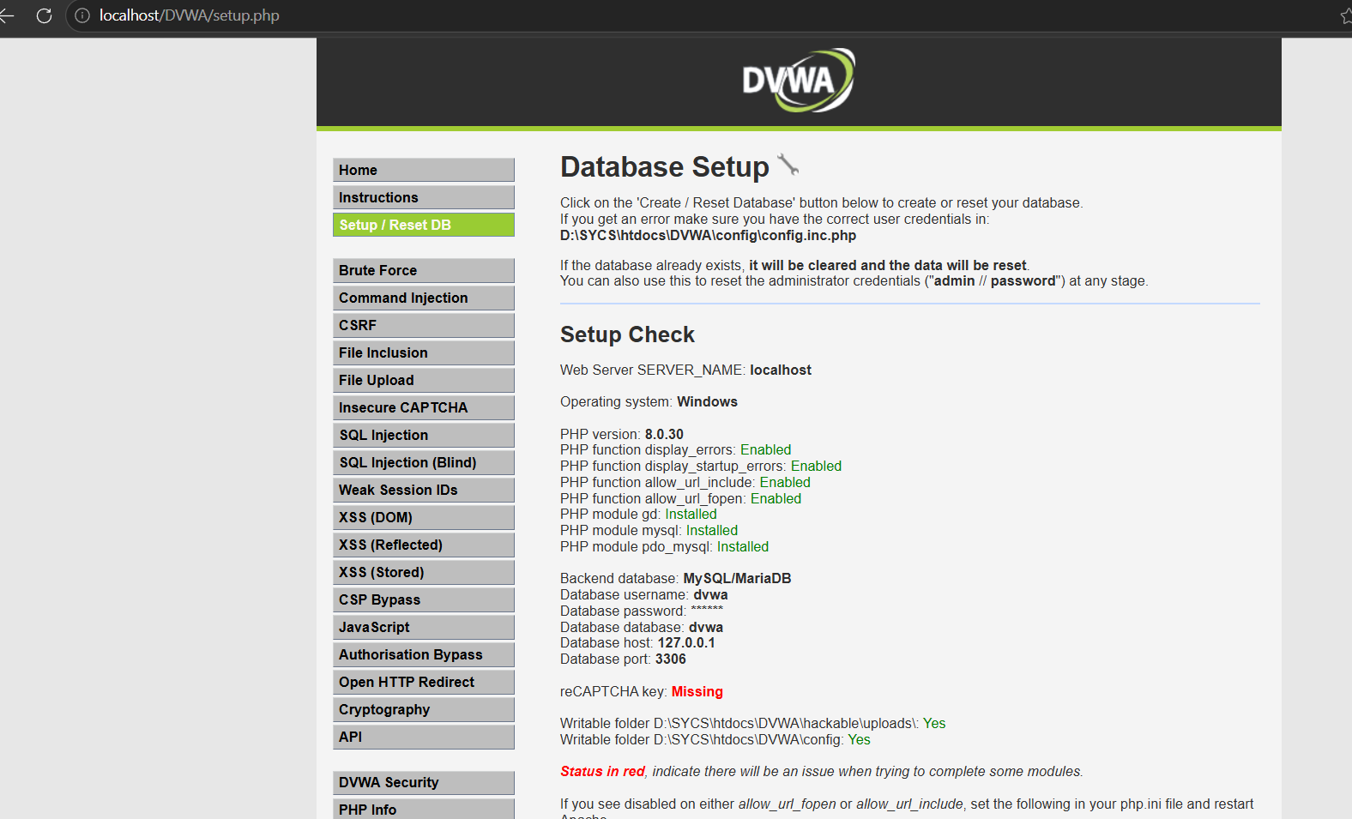
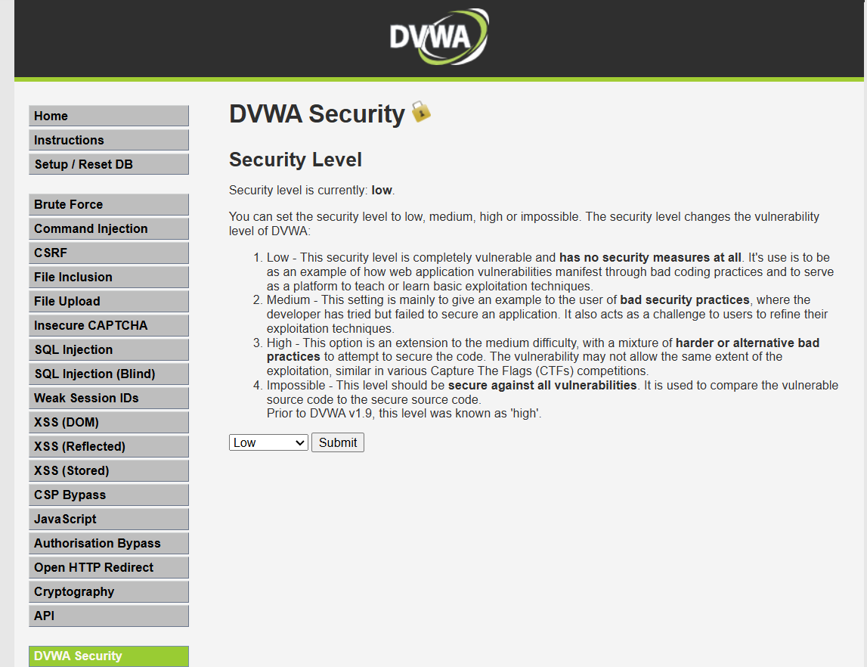
Type 1
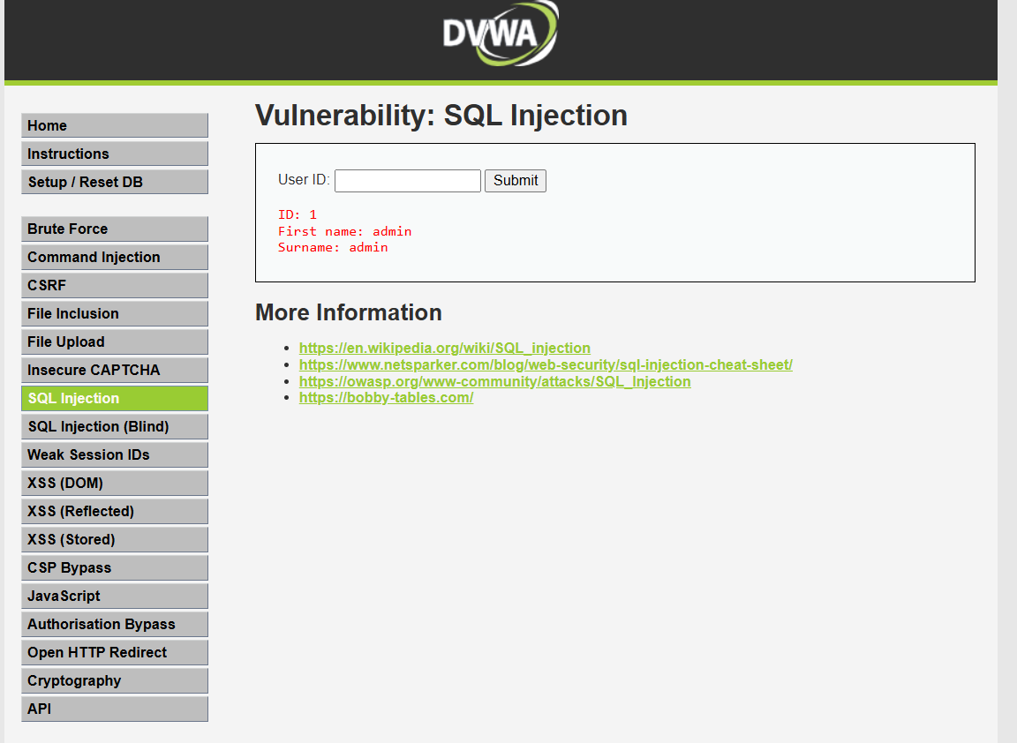
Type 1’ or tue;# and click on submit.
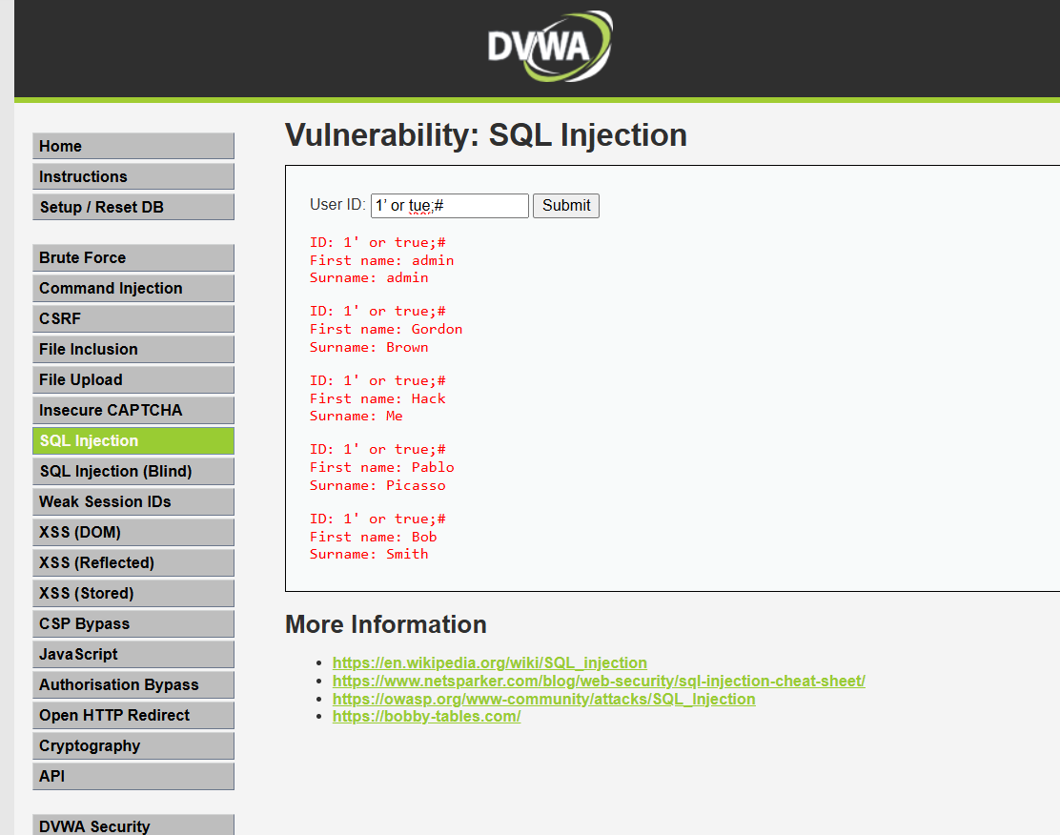
Login to http://testfire.net/login.jsp
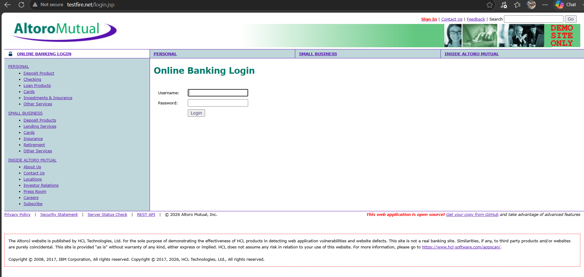
Type username as admin and password as admin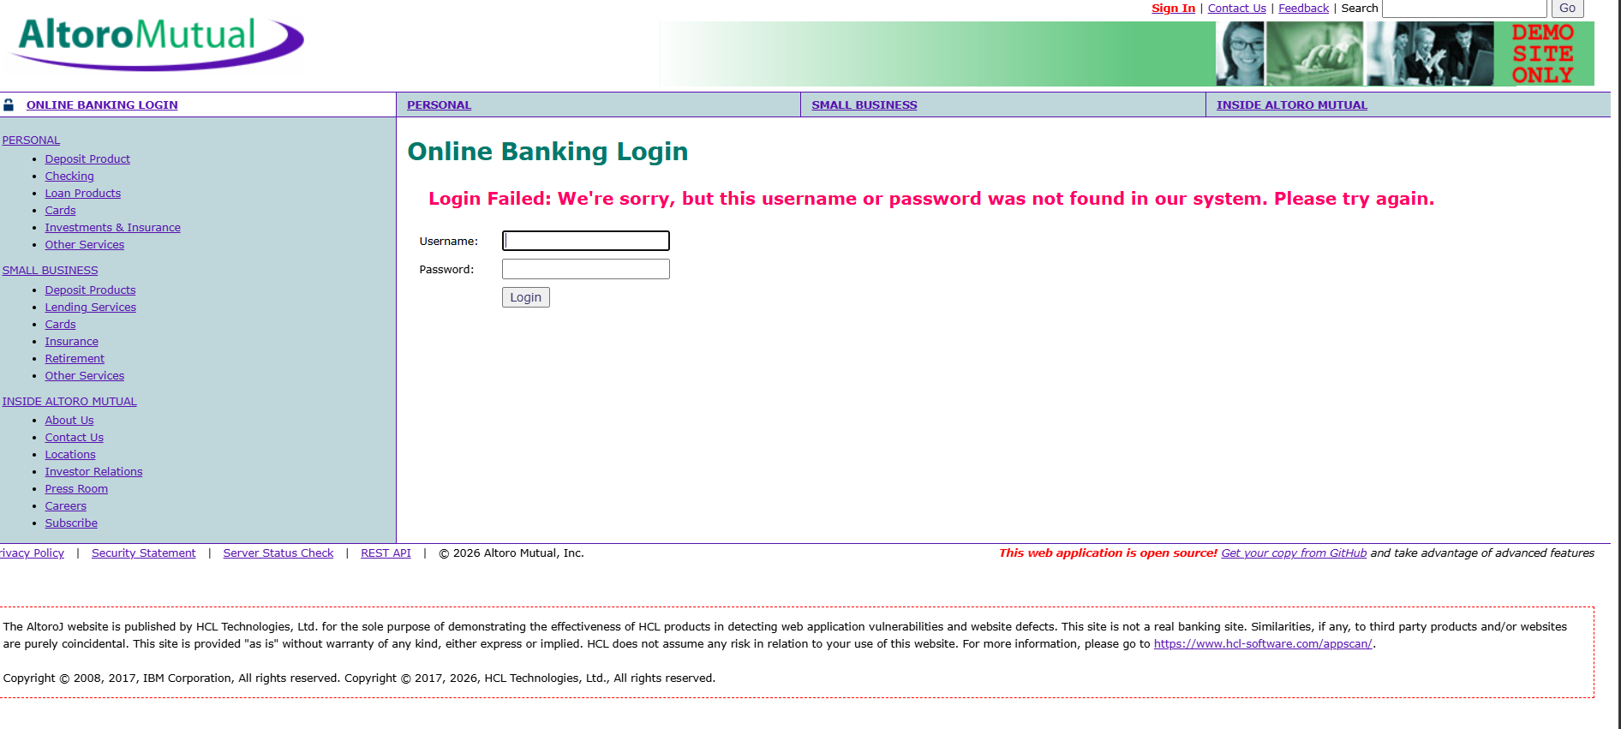
Now type username as ' OR 1=1-- and type any password you want
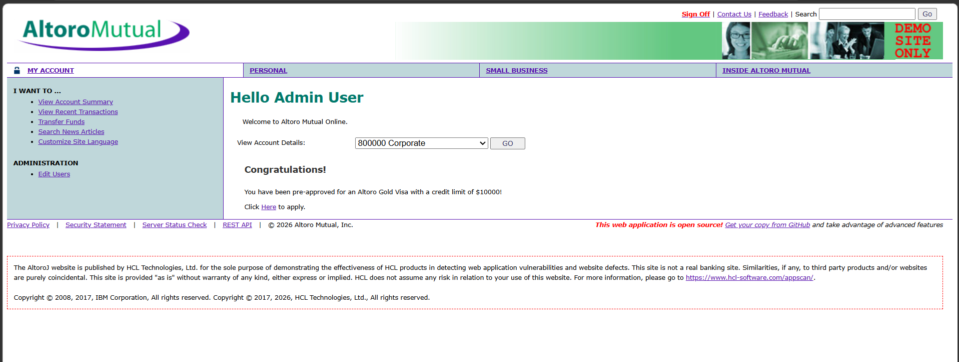
You have successfully logged in as admin user by injecting malicious code.

